**1 ) Pull & Merge**

- Basically Pull command is used for Pull the repository from the server to the local machine. For that

1) First of all we have to set the remote origin using this commad

- **git remote add origin (Link of server Repository)**

2) Now we can pull the repository from server to local machine like this

**- git pull origin master**

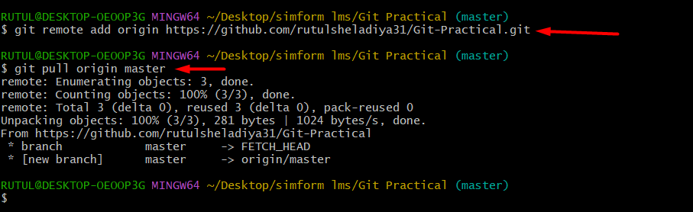

**Merge**

- Basically merge command is used for merge the two repository with each other like this

- for merging I have created feature-a branch. Feature-a branch merge with master branch.

**- Git merge ( branch name name which you want to merge with master branch )**

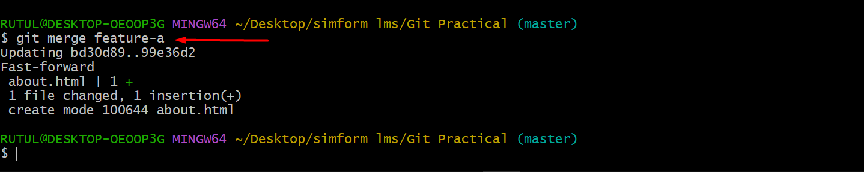

**2) Rebase**

- Basically rebase command is use for that merge or joint all the commit of one branch with another branch.

- for rebase I have created feature-rebase branch and rebase the feature-rebase branch with master branch.

**Example :**

- Here we create the feature-rebase branch that branch contain two commit

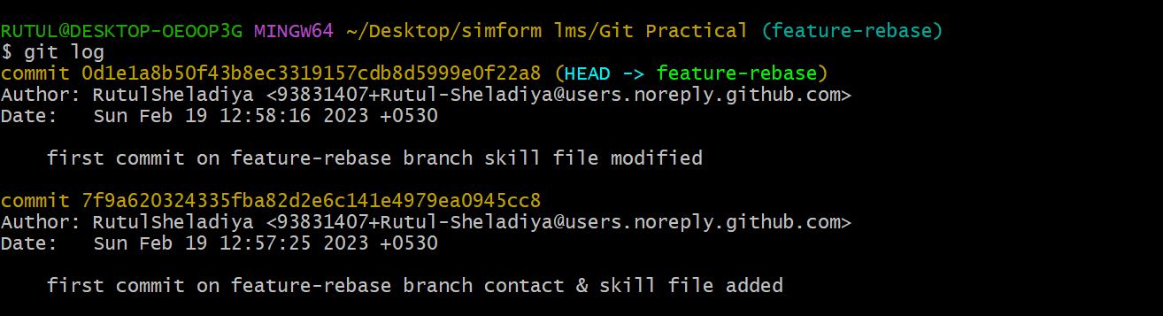

- Now if we are rebase the feature-rebase branch with master branch then both commit of feature-rebase branch are joined with master branch like this

**- Git rebase (Branch name)**

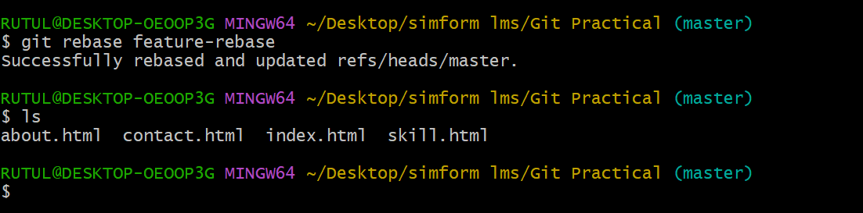

**3) change commit message**

- Basically it is use for changing the commit message. We can change the commit message using amend like this

- I for change the commit I had use the feature-a branch.

**Git commit --amend**

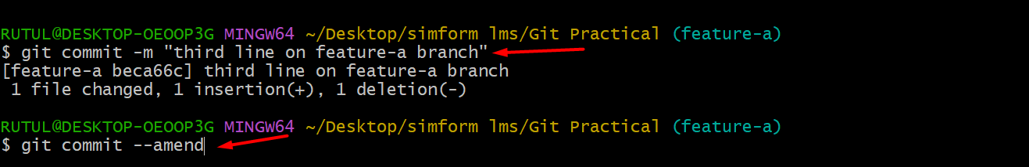

After entering this commad : git commit --amend VI editor will open and there we have to change the commit message like this

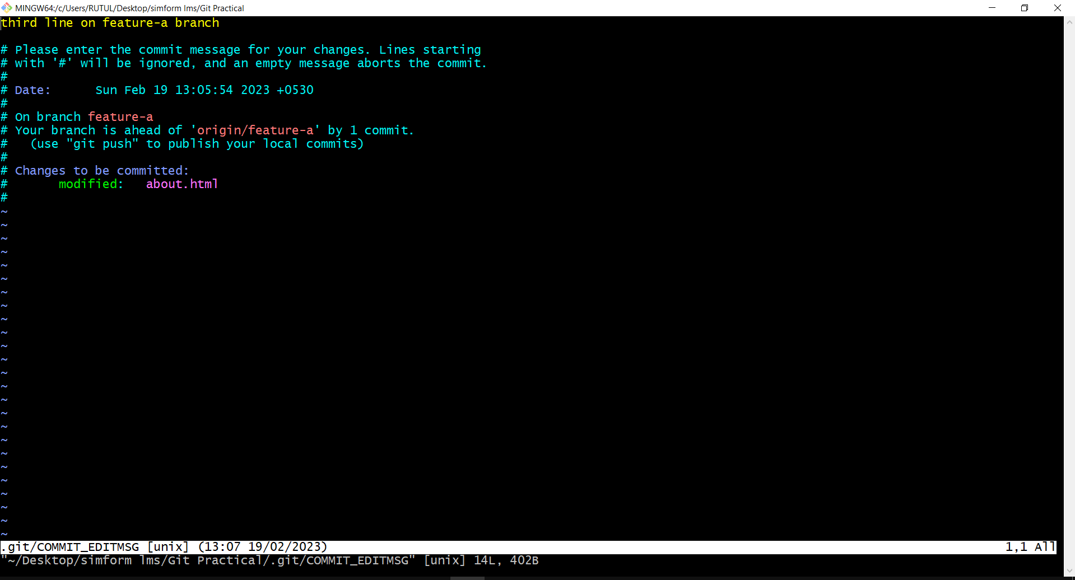

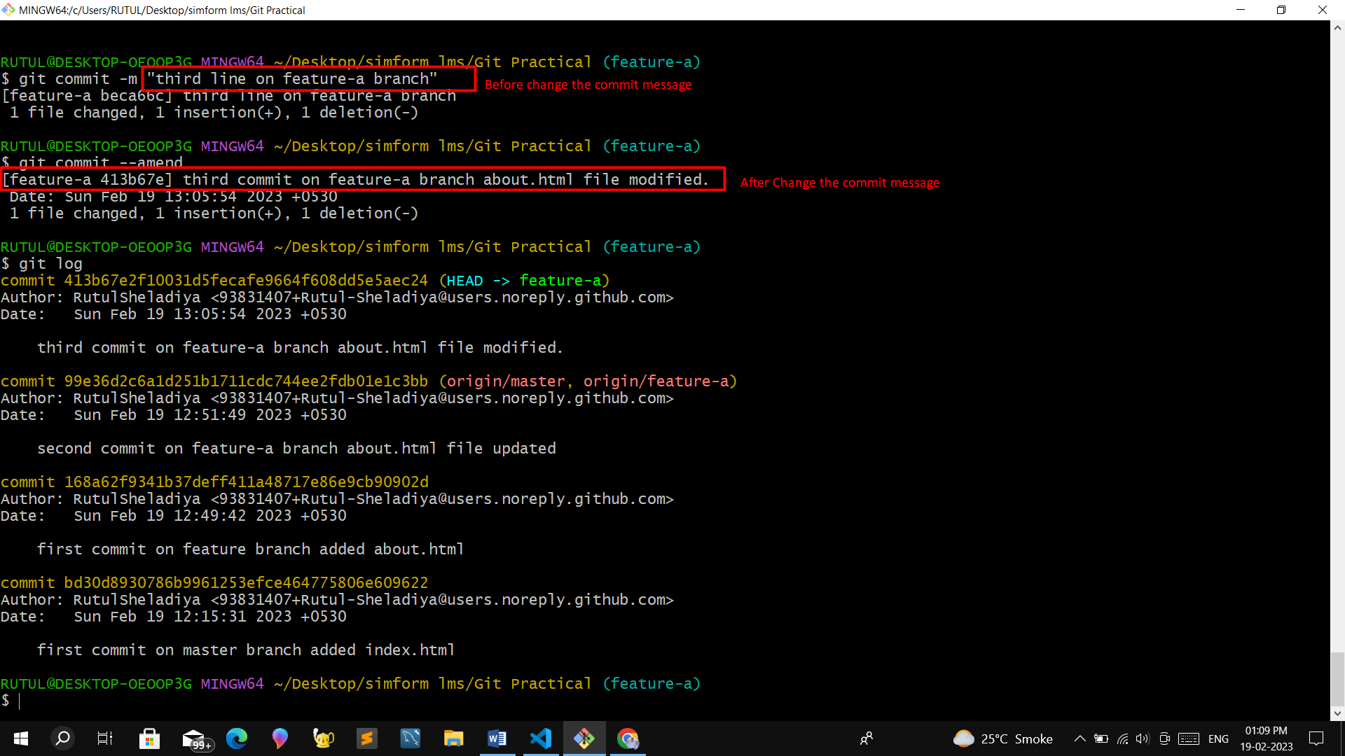

**4) cherry-pick**

- Basically cherry-pick command is use for pick the specific commit from the another branch.

- For cherry-pick we have create new branch feature-cherrypick. Basically this branch contain 3 commit like this

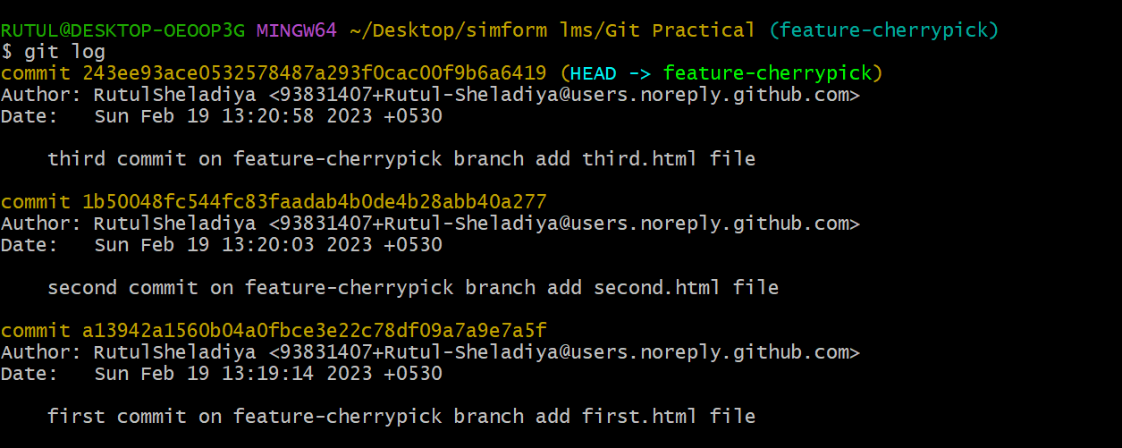

- Now we have to add third commit or feature on master branch then we can write like this

1) first we checkout on master branch and we can see here total 4 files on master branch.

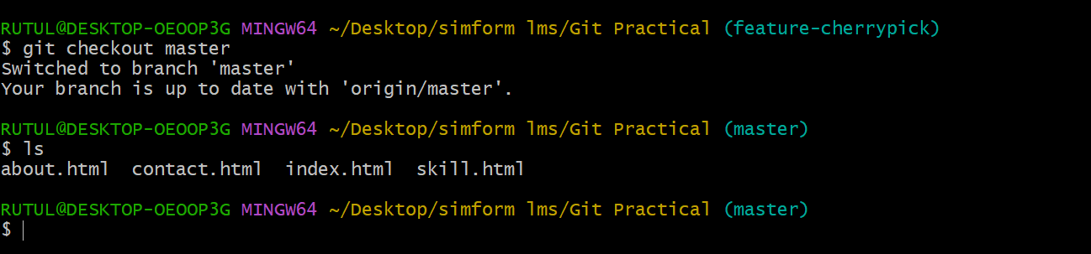

2) now we will add first.html file of feature-cherrypick branch on master branch using this command.

**Git cherry-pick (hash code of third commit)**

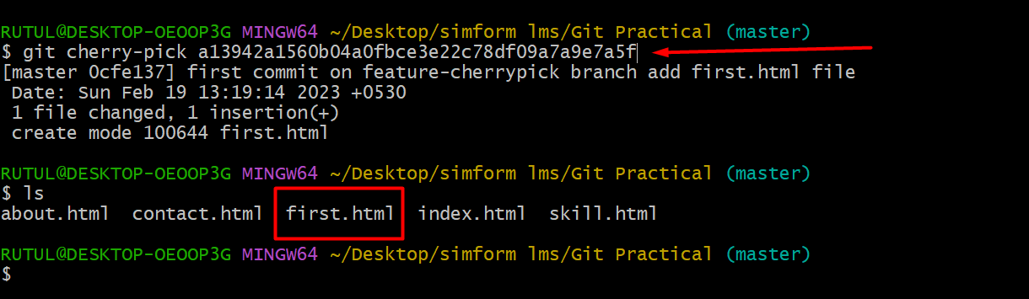

**5) Drop The Commit**

- Basically for drop the commit we can use the reset command. in any branch the HEAD pointer point the lastest commit. We can drop the commit using 3 ways.

- for drop the commit I had use the feature-a branch from this branch I had drop the commit.

**Soft** – Drop the commit from local repo and jump to the Staging Area.

**Mixed** - Drop the commit from local repo and jump to the Working Directory.

**Hard** - Drop the commit from local repo and permanently delete the file.

Example : I want to drop the first commit from feature-a branch then we can write command like this

**Git reset --hard HEAD~1**

It will drop the first commit

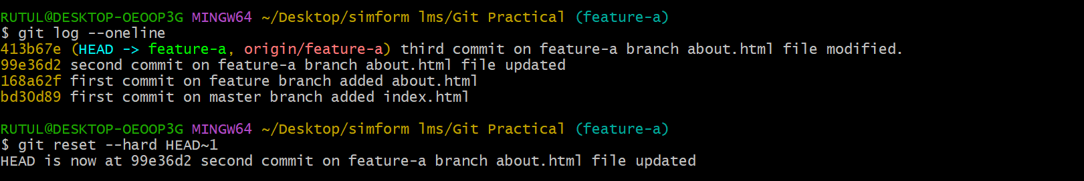

Now we can see head pointer moves to the next commit

